Vision Statement of the Department.
To be a preferred hub for nurturing computer engineering aspirants through innovative, ethical, value-based technical education, impactful research, and industry collaboration, to become successful professionals contributing for the betterment of society.
Mission Statement of the Department.
To nurture computer engineering professionals by offering Dynamic learning environment that encourages problem-solving using emerging technology, National Education Policy aligned evidence-based technical education, fostering ,innovation, research, and industry–institute collaboration & Holistic, ethical and sustainable development for lifelong success.

Session 2026-2027
Vision:Dream of where you want. | Mission: Means to achieve Vision
Program Educational Objectives of the program (PEO): (broad statements that describe the professional and career accomplishments)
PEO1 | Preparation | P: Preparation | Pep-CL abbreviation pronounce as Pep-si-lL easy to recall
PEO2 | Core Competence | E: Environment  (Learning Environment) | Pep-CL abbreviation pronounce as Pep-si-lL easy to recall
PEO3 | Breadth | P: Professionalism | Pep-CL abbreviation pronounce as Pep-si-lL easy to recall
PEO4 | Professionalism | C: Core Competence | Pep-CL abbreviation pronounce as Pep-si-lL easy to recall
PEO5 | Learning  Environment | L: Breadth (Learning in diverse areas) | Pep-CL abbreviation pronounce as Pep-si-lL easy to recall
Program Outcomes (PO): (statements that describe what a student should be able to do and know by the end of a program)
Keywords of POs:
Engineering knowledge,Problem analysis, Design/development of solutions,Conduct Investigations of Complex Problems, Engineering Tool Usage, The Engineer and The World,Ethics, Individual and Collaborative Team work,Communication, Project Management and Finance, Life-Long Learning
PSO Keywords: Cutting edge technologies, Research
“I am an engineer, and I know how to apply engineering knowledge to investigate, analyse and design solutions to complex problems using tools for entire world following all ethics in a collaborative way with proper management skills throughout my life.” to contribute to the development of cutting-edge technologies and Research.
Integrity: I will adhere to the Laboratory Code of Conduct and ethics in its entirety.

Name and Signature of Student and Date
(Signature and Date in Handwritten)
Vision Statement of the Department.
To be a preferred hub for nurturing computer engineering aspirants through innovative, ethical, value-based technical education, impactful research, and industry collaboration, to become successful professionals contributing for the betterment of society.
Mission Statement of the Department.
To nurture computer engineering professionals by offering Dynamic learning environment that encourages problem-solving using emerging technology, National Education Policy aligned evidence-based technical education, fostering ,innovation, research, and industry–institute collaboration & Holistic, ethical and sustainable development for lifelong success.
Session | 2024-25 (ODD) |  | Course Name | Web Technology Lab
Semester | 3 |  | Course Code | 23CT1301
Roll No | 63 |  | Name of Student | Shakul  Vilas  Rathod
Practical Number
Course Outcome |  | - Understand various internet technologies.  - Design the web pages using HTML and CSS.  - Implement the XML technology to store the data.  - Develop the interactive web pages using JavaScript.
Aim |  | Study HTML Tags and to implement basic Web page.
Problem Definition |  | To study the basic HTML tags and implement a simple web page using HTML. The practical aims to understand the basic structure of an HTML document and demonstrate the use of different HTML5 elements such as headings, paragraphs, links, lists, header, navigation, section, article, aside, and footer.
Theory  (100 words) |  | HTML stands for HyperText Markup Language and is used to create the structure of web pages. HTML uses tags and elements to define headings, paragraphs, links, images, lists, tables, and other webpage content. A basic HTML document contains <!DOCTYPE html>, <html>, <head>, <title>, and <body> elements. HTML5 introduced semantic elements such as <header>, <nav>, <section>, <article>, <aside>, and <footer> to provide better structure and meaning to web pages. It also supports features such as audio, video, canvas, geolocation, local storage, and drag-and-drop. HTML documents are interpreted and displayed by web browsers.
Procedure and Execution  (100 Words) |  | Step for Implementation:  1. Open a text editor such as VS Code or Notepad.  2. Create a new file and save it with the .html extension.  3. Write the basic HTML structure using <!DOCTYPE html>, <html>, <head>, and <body> tags.  4. Add a suitable page title using the <title> tag.  5. Use heading and paragraph tags such as <h1> and <p> to display basic content.  6. Create a navigation section using the <nav>, <ul>, <li>, and <a> tags.  7. Use HTML5 semantic elements such as <header>, <article>, <section>, <aside>, and <footer>.  8. Add hyperlinks using the <a> tag to demonstrate navigation between web resources.  9. Save the HTML file and open it in a web browser.  10. Observe the displayed webpage and verify that all HTML elements are properly rendered.  HTML :  HTML stands for HyperTextMarkup Language. It creates a complete website structure of web pages.  HTML is a combination of Hypertext and Markup language. Hypertext defines the link between the web  pages and markup language defines the text document within the tag. This HTML Tutorial provides basic  to advanced concepts for beginners and professionals.  HTML is a markup language used by the browser to manipulate text, images, and other content, in order to  display it in the required format. HTML was created by Tim Berners-Lee in 1991. The first-ever version of  HTML was HTML 1.0, but the first standard version was HTML 2.0, published in 1995.  Basic Structure of Web Page  The basic structure of an HTML page is given below. It contains the essential building-block elements (i.e.  doctype declaration, HTML, head, title, and body elements) to create web page.  HTML Basic Elements  ∙ &lt;DOCTYPE! html&gt; – A doctype or document type declaration is an instruction that tells the web  browser about the markup language in which the current page is written. It is not an element or  tag. The doctype declaration is not case-sensitive.  ∙ &lt;html&gt; – It is used to define the root element of an HTML document. This tag tells the browser that  it is an HTML document. It is the second outer container element that contains all other  elements within it.  ∙ &lt;head&gt; – This tag is used to define the head portion of the HTML document. It contains  information related to the document. Elements within the head tag are not visible on the  webpage.  ∙ &lt;body&gt; – It is used to enclose all visible content of a webpage. In other words, the body content is  what the browser will show on the front end.  Example  &lt;!DOCTYPE html&gt;  &lt;html&gt;  &lt;!-- Head Section content --&gt;  &lt;head&gt;  &lt;!-- Page title --&gt;  &lt;title&gt;Basic Web Page&lt;/title&gt;  &lt;/head&gt;  &lt;!-- Body Section content --&gt;  &lt;body&gt;  &lt;!-- Used to display heading content --&gt; &lt;h1&gt;Welcome to Web  Technology Lab&lt;/h1&gt;  &lt;!-- Used to display paragraph content --&gt; &lt;p&gt;A Computer Science portal  for Web Developer&lt;/p&gt; &lt;/body&gt;  &lt;/html&gt;  HTML5  HTML5 is the next major revision of the HTML standard superseding HTML 4.01, XHTML 1.0,and  XHTML 1.1. HTML5 is a standard for structuring and presenting content on the WorldWide Web.  HTML5 is a cooperation between the World Wide Web Consortium (W3C) and the WebHypertext  Application Technology Working Group (WHATWG).  The new standard incorporates features like video playback and drag-and-drop that havebeen  previously dependent on third-party browser plug-ins such as Adobe Flash, MicrosoftSilverlight,  and Google Gears.  Browser Support:  The latest versions of Apple Safari, Google Chrome, Mozilla Firefox, and Opera all supportmany  HTML5 features and Internet Explorer 9.0 will also have support for some HTML5functionality. The  mobile web browsers that come pre-installed on iPhones, iPads, and Android phones allhave  excellent support for HTML5.  New Features:  HTML5 introduces a number of new elements and attributes that can help you in building modern  websites. Here is a set of some of the most prominent features introduced in HTML5. ∙ New Semantic  Elements: These are like &lt;header&gt;, &lt;footer&gt;, and &lt;section&gt;. ∙ Forms 2.0: Improvements to HTML  web forms where new attributes have beenintroduced for &lt;input&gt; tag.  ∙ Persistent Local Storage: To achieve without resorting to third-party plugins. ∙ WebSocket :  A next-generation bidirectional communication technology for webapplications.  ∙ Server-Sent Events: HTML5 introduces events which flow from web server to theweb  browsers and they are called Server-Sent Events (SSE).  ∙ Canvas: This supports a two-dimensional drawing surface that you can program  withJavaScript.  ∙ Audio &amp; Video: You can embed audio or video on your webpages without resortingto third-  party plugins.  ∙ Geolocation: Now visitors can choose to share their physical location with your  webapplication.  ∙ Microdata: This lets you create your own vocabularies beyond HTML5 and extend yourweb  pages with custom semantics.  ∙ Drag and drop: Drag and drop the items from one location to another location on thesame  webpage.  Backward Compatibility:  HTML5 is designed, as much as possible, to be backward compatible with existing webbrowsers.  Its new features have been built on existing features and allow you to providefallback content for  older browsers.  It is suggested to detect support for individual HTML5 features using a few lines of JavaScript.  HTML5 – SYNTAX  The HTML 5 language has a &quot;custom&quot; HTML syntax that is compatible with HTML 4 andXHTML1  documents published on the Web, but is not compatible with the more esoteric SGMLfeatures of  HTML 4.  HTML 5 does not have the same syntax rules as XHTML where we needed lower case tagnames,  quoting our attributes; an attribute had to have a value and to close all emptyelements. HTML5  comes with a lot of flexibility and it supports the following features − ∙ Uppercase tag names.  ∙ Quotes are optional for attributes.  ∙ Attribute values are optional.  ∙ Closing empty elements are optional  The DOCTYPE  DOCTYPEs in older versions of HTML were longer because the HTML language was SGML  basedand therefore required a reference to a DTD.  HTML 5 authors would use simple syntax to specify DOCTYPE as follows:  &lt;!DOCTYPE html&gt;  The above syntax is case-insensitive.  Character Encoding  HTML 5 authors can use simple syntax to specify Character Encoding as follows – &lt;meta  charset=&quot;UTF-8&quot;&gt;  The charset attribute specifies the character encoding for the HTMLdocument. The HTML5  specification encourages web developers touse the UTF-8 character set, which covers  almost all of the charactersand symbols in the world!  The &lt;script&gt; tag  It&#39;s common practice to add a type attribute with a value of &quot;text/javascript&quot; to script  Elementsas follows −  &lt;script type=&quot;text/javascript&quot; src=&quot;scriptfile.js&quot;&gt;&lt;/script&gt;  HTML 5 removes extra information required and you can use simply following syntax – &lt;script  src=&quot;scriptfile.js&quot;&gt;&lt;/script&gt;  The &lt;link&gt; tag  So far you were writing &lt;link&gt; as follows –  &lt;link rel=&quot;stylesheet&quot; type=&quot;text/css&quot; href=&quot;stylefile.css&quot;&gt; HTML 5 removes extra  information required and you can simply use the following syntax –&lt;link  rel=&quot;stylesheet&quot; href=&quot;stylefile.css&quot;&gt;  HTML5 Document  The following tags have been introduced for better structure − ∙ section: This tag represents a  generic document or application section. It can be usedtogether with h1-h6 to indicate the  document structure.  ∙ article: This tag represents an independent piece of content of a document, such asa blog  entry or newspaper article.  ∙ aside: This tag represents a piece of content that is only slightly related to the rest ofthe  page.  ∙ header: This tag represents the header of a section.  ∙ footer: This tag represents a footer for a section and can contain information aboutthe author,  copyright information, et cetera.  ∙ nav: This tag represents a section of the document intended for navigation. ∙  dialog: This tag can be used to mark up a conversation.  ∙ figure: This tag can be used to associate a caption together with some embeddedcontent,  such as a graphic or video.  The markup for an HTML 5 document would look like the following – &lt;!DOCTYPE  html&gt;  &lt;html&gt;  &lt;head&gt;  &lt;meta charset=&quot;utf-8&quot;&gt;  &lt;title&gt;...&lt;/title&gt;  &lt;/head&gt;  &lt;body&gt;  &lt;header&gt;...&lt;/header&gt;  &lt;nav&gt;...&lt;/nav&gt;  &lt;article&gt;  &lt;section&gt;  ...  &lt;/section&gt;  &lt;/article&gt;  &lt;aside&gt;...&lt;/aside&gt;  &lt;footer&gt;...&lt;/footer&gt;  &lt;/body&gt;  &lt;/html&gt;  Example:  &lt;!DOCTYPE html&gt;  &lt;html&gt;  &lt;head&gt;  &lt;meta charset=&quot;utf-8&quot;&gt;  &lt;title&gt;...&lt;/title&gt;  &lt;/head&gt;  &lt;body&gt;  &lt;header role=&quot;banner&quot;&gt;  &lt;h1&gt;HTML5 Document Structure Example&lt;/h1&gt;  &lt;p&gt;This page should be tried in safari, chrome or Mozila.&lt;/p&gt; &lt;/header&gt;  &lt;nav&gt;  &lt;ul&gt;  &lt;li&gt;&lt;a href=&quot;https://infyspringboard.onwingspan.com&quot;&gt;HTML Tutorial&lt;/a&gt;&lt;/li&gt; &lt;li&gt;&lt;a  href=&quot;https://infyspringboard.onwingspan.com&quot;&gt;CSS Tutorial&lt;/a&gt;&lt;/li&gt; &lt;li&gt;&lt;a  href=&quot;https://infyspringboard.onwingspan.com&quot;&gt;JavaScript Tutorial&lt;/a&gt;&lt;/li&gt; &lt;/ul&gt;  &lt;/nav&gt;  &lt;article&gt;  &lt;section&gt;  &lt;p&gt;Once article can have multiple sections&lt;/p&gt;  &lt;/section&gt;  &lt;/article&gt;  &lt;aside&gt;  &lt;p&gt;This is aside part of the web page&lt;/p&gt;  &lt;/aside&gt;  &lt;footer&gt;  &lt;p&gt;Created by &lt;a href=&quot;https://infyspringboard.onwingspan.com&quot;&gt;Sneha&lt;/a&gt;&lt;/p&gt; &lt;/footer&gt;  &lt;/body&gt;  &lt;/html&gt;
Vision Statement of the Department.
To be a preferred hub for nurturing computer engineering aspirants through innovative, ethical, value-based technical education, impactful research, and industry collaboration, to become successful professionals contributing for the betterment of society.
Mission Statement of the Department.
To nurture computer engineering professionals by offering Dynamic learning environment that encourages problem-solving using emerging technology, National Education Policy aligned evidence-based technical education, fostering ,innovation, research, and industry–institute collaboration & Holistic, ethical and sustainable development for lifelong success.
 | Output: 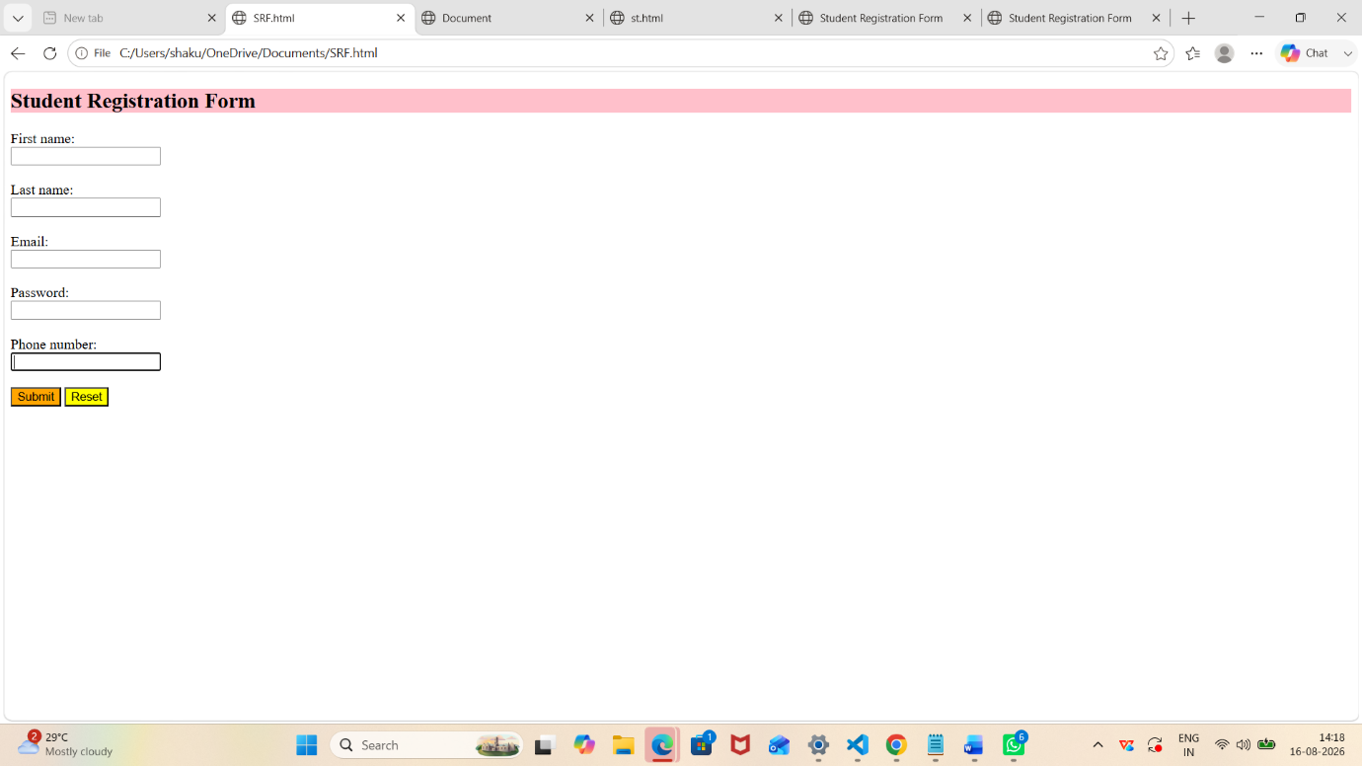
Output Analysis | The basic web page was successfully created using HTML and HTML5 semantic tags. The webpage contains a header, navigation menu, article, section, aside, and footer. Headings, paragraphs, lists, and hyperlinks are displayed correctly in the browser. The practical demonstrates how HTML tags are used to structure and organize the content of a web page. The use of semantic HTML5 elements also makes the structure of the webpage clear and meaningful.
Link of student Github profile where lab assignment has been uploaded | https://github.com/shakulvilasrathod-art/Web-technology
Conclusion | The practical successfully demonstrated the study and implementation of basic HTML tags. A structured web page was created using HTML5 elements such as header, navigation, section, article, aside, and footer. The experiment helped in understanding the basic structure of HTML documents and the role of different tags in developing web page.
Plag Report (Similarity index < 12%)
Date | 16-08-2026

